AssignmentCode:DA-AG-013

IntroductiontoPowerBI,Charts,DAX&Creating Reports

Question 1: Define Power BI and explain the key components of thePowerBIecosystem
PowerBIisabusinessintelligence(BI)anddatavisualizationtooldevelopedbyMicrosoft.Ithelpsusers collect data from multiple sources, transform and model that data, and create interactive reports and dashboards for effective decision-making.

ThePowerBIecosystemconsistsofthefollowingcomponents:

PowerBIDesktop
Power BI Desktop is a free Windows application used to create reports and data models. It allows users to connect to various data sources, clean and transform data using Power Query, build relationships between tables, and create interactive visualizations. Reports created in Power BI Desktop can be published to the Power BI Service.

PowerBIService
Power BI Service is a cloud-based platform used to publish, share, and collaborate on reports and dashboards. It allows users to access reports via a web browser, schedule data refreshes,manage workspaces, and share insights with others.

PowerBIMobile
Power BI Mobile is a mobile application available on Android, iOS, and Windows devices. It enables users to view and interact with reports and dashboards on mobile devices, providing access to business insights anytime and anywhere.

PowerBIGateway
Power BI Gateway acts as a bridge between on-premises data sources and the Power BI Service.It enablessecuredatatransferandscheduledrefreshofdatastoredlocallywithoutmovingthedatato thecloud.

Question 2: Compare Power BI visuals and explain when to use them

PieChartvsDonutChart
Bothchartsareusedtorepresentpartsofawhole.

Feature PieChart DonutChart

Shape | Solidcircularchart | Circularchartwithacenterhole
Readability | Simple forfewcategories | Betterlabelvisibility
Centervalue | Notavailable | Candisplaytotalvalue
PieChart–Whentouse:Usedwhenthereareveryfewcategoriesandtheobjectiveistoshowsimple percentagedistribution.

Example:Percentageofsalesbyproductcategory.

DonutChart–Whentouse:Usedwhenshowingpercentagedistributionalongwithakeyvalueinthe center.

Example:Salescontributionbyregionwithtotalsalesshowninthecenter.

BarChartvsColumnChart

Feature BarChart ColumnChart

Orientation | Horizontal | Vertical
Bestuse | Longcategorynames | Time-basedcomparisons
Readability | Betterformanycategories | Betterfortrends
BarChart–Whentouse:Usedwhentherearemanycategoriesorlongcategorynames.

Example:Salesbyproductsub-category.

ColumnChart–Whentouse:Usedforcomparingvaluesovertime.

Example:Monthlysalestrend.

Question3:Explainthesignificanceofdatamodelingconceptsin Power BI

StarSchemavsSnowflakeSchema
StarSchemaconsistsofacentralfacttableconnecteddirectlytomultipledimensiontables.

Significance: -Simpleandeasytounderstand-Fasterperformance-PreferredschemainPowerBI- Efficient for DAX calculations

SnowflakeSchemainvolvesnormalizeddimensiontablesconnectedtoeachother.

Significance: - Reduces data redundancy - More complex relationships - Slower performance - Less preferred for Power BI reporting

PowerBIperformsbestwithaStarSchema.

PrimaryKeyvsForeignKeyinPowerBI
PrimaryKeyuniquelyidentifiesrecordsinatableandisusuallypresentindimensiontables.

ForeignKeyexistsinthefacttableandreferstotheprimarykeyofarelateddimensiontable.

Example:CustomerIDinCustomerstable(PrimaryKey)andCustomerIDinSalestable(ForeignKey).

ImportanceofCardinality
Cardinalitydefinestherelationshipbetweentables,suchasone-to-manyormany-to-many.

Whyitisimportant:-Ensurescorrectdataaggregation-Controlsfilterflowbetweentables-Prevents duplicate or incorrect values - Improves performance and accuracy of reports

Question 4: Differentiate between Calculated Column and Measure
Feature CalculatedColumn Measure

Calculationtime | Duringdatarefresh | Atquerytime
Storage | Storedinmodel | Notstored
Context | Rowcontext | Filtercontext
Usage | Categorizationandfiltering | AggregationsandKPIs
Performance | Increasesmodelsize | Moreefficient
CalculatedColumnExample:ProfitCategory=IF([Profit] >0,"Profit","Loss")

MeasureExample:TotalSales=SUM(Sales[SalesAmount])

Row Context
Rowcontextmeanscalculationsareevaluatedrowbyrow.

Example:Profit=Sales–Costcalculatedforeachrow.

FilterContext
Filtercontextreferstofiltersappliedbyslicers,visuals,orpagefilters.

Example:TotalSalescalculatedonlyforaselected region.

Question 5: Difference between a Report and a Dashboard in Power BI

PowerBIReport
A report is created in Power BI Desktop and can contain multiple pages with interactive visuals for detailedanalysis.

Features:-Multiplepages-Highinteractivity-Basedononedataset-Usedfordetailedanalysis

Example:Salesperformancereportwithmultipleanalysispages.

PowerBIDashboard
A dashboard is created in Power BI Service and consists of a single page containing pinned visuals from one or more reports.

Features:-Singlepage-Limitedinteractivity-Canusemultipledatasets-Usedforhigh-leveloverview

Example:Executivedashboard showingkey KPIs.

ComparisonSummary

Feature Report Dashboard

Pages | Multiple | Single
Creation | PowerBIDesktop | PowerBIService
Interactivity | High | Limited
Datasources | Singledataset | Multipledatasets
Purpose | Detailed analysis | Summaryview
Question 6 : Using the Sample Superstore dataset: ● Create a Clustered Bar Chart to display Total Sales by Sub-Category ● Create a Donut Chart for Sales % by Region Provide screenshots of both visuals.

Question 6 – Insights
(Clustered Bar: Sales by Sub-Category | Donut: Sales % by Region)
- Sales vary significantly across sub-categories, with a few sub-categories contributing the majority of total sales.
- Some sub-categories show consistently lower sales, indicating lower demand or limited market reach.
- The donut chart shows that sales contribution is uneven across regions.
- One or two regions dominate total sales, while others have comparatively lower performance

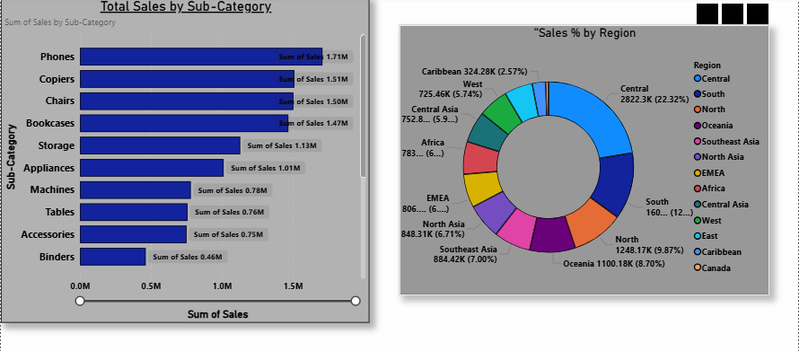

Question 7 : Write and apply the following measures: ● Total Profit = SUM([Profit]) ● Average Discount = AVERAGE([Discount]) Display both in a KPI Card, and use a Line Chart to show profit trend over months. Add visuals and DAX formulas.

Question 7 – Insights
(KPI Cards + Line Chart)
- The Total Profit KPI shows the overall profitability of the business.
- The Average Discount indicates the general discounting strategy used across orders.
- The line chart reveals fluctuations in profit over different months.
- Certain months show higher profitability, suggesting possible seasonal demand patterns.

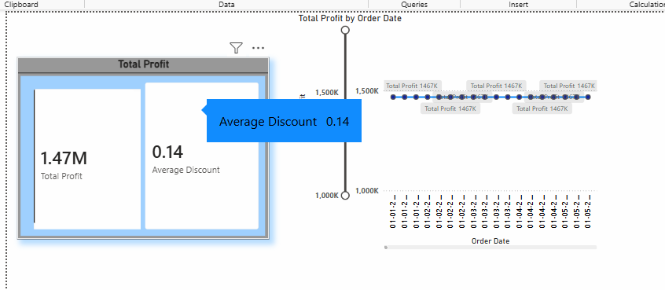

Question 8 : Implement a DAX measure that calculates the percentage of total sales by product category.

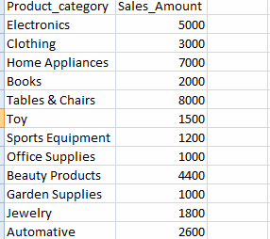

Question 8 – Insights
(Sales % by Product Category)
- Product categories contribute unequally to total sales.
- Categories like high-value items contribute a larger percentage of total sales.
- Low-performing categories have minimal impact on overall revenue.
- Percentage-based analysis helps identify priority product categories for business focus.

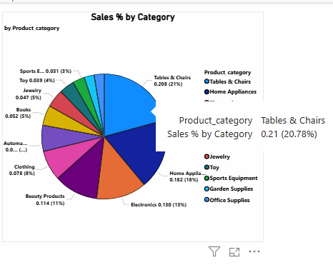

Question 9 :
● Create a DAX Measure for Total Profit

● Use it in a Waterfall Chart to analyze how different Sub-Categories contribute to overall profit

● Add a Slicer for Region to filter the visual

● Write brief business insights (4–5 lines) from the chart and provide 2–3 data-driven recommendations to improve profit.

Provide a steps, screenshot of the Waterfall chart and the DAX formula

Question 9 – Insights
(Waterfall Chart + Region Slicer)
- The Waterfall chart highlights how individual sub-categories contribute positively or negatively to total profit.
- Some sub-categories generate significant profit, while others reduce overall profitability.
- Regional slicer analysis shows that profit contribution varies by region.
- Loss-making sub-categories are more prominent in certain regions.

Recommendations (Q9)
- Focus on expanding high-profit sub-categories.
- Re-evaluate pricing and costs for loss-making sub-categories.
- Apply region-specific strategies to improve profitability.

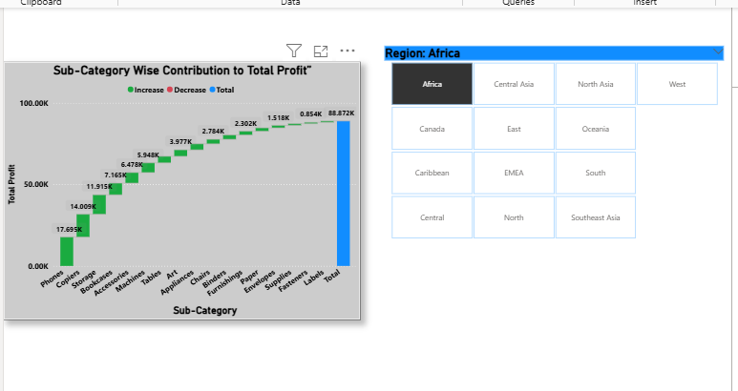

Question 10 : Scenario:
VitaTrack Wellness, a digital health company in FitZone, has collected data on users’ daily habits and health vitals. The analytics team is tasked with drawing actionable insights from this data to improve lifestyle suggestions and prevent heart-related risks.

Your Task:
Using the provided dataset (includes Age, Gender, BMI, Steps, Calories, Sleep, Heart Rate, Blood Pressure, Smoking, Alcohol, Exercise, Diabetic & Heart Disease status)

Build a one-page Power BI dashboard that answers:
1. Are users maintaining a balanced lifestyle (Steps, Sleep, Calories)
2. What lifestyle patterns (Smoking, Alcohol, BMI, etc.) indicate heart disease risk?
3. Is there any visible relationship between Sleep and Physical Activity?
4. How does BMI vary across Age Groups and Genders?
5. What is the impact of smoking and alcohol on heart rate and blood pressure?
6. Segment people based on their health activity to suggest lifestyle changes

Question 10 – Insights
(Health Dashboard)
- Most users maintain moderate physical activity levels, but sleep duration varies widely.
- Smoking and alcohol consumption are associated with a higher occurrence of heart disease.
- Users with better sleep patterns tend to show higher physical activity levels.
- BMI increases with age and differs slightly across genders.
- Low physical activity groups show higher health risk indicators.

Lifestyle Recommendations (Q10)
- Encourage low-activity users to increase daily physical activity.
- Promote healthy lifestyle habits such as reduced smoking and alcohol consumption.
- Target high-risk groups with personalized health improvement programs.

Ans 10.1

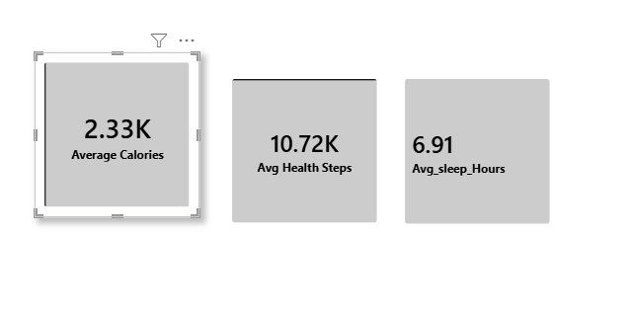

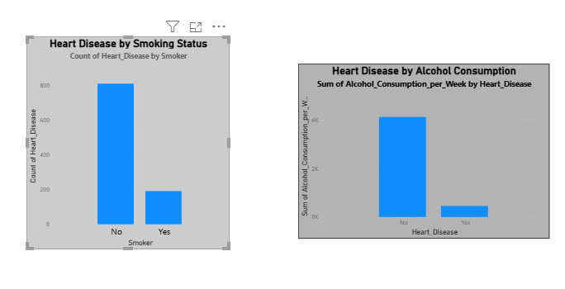
Ans 10.2

Ans. 10.3

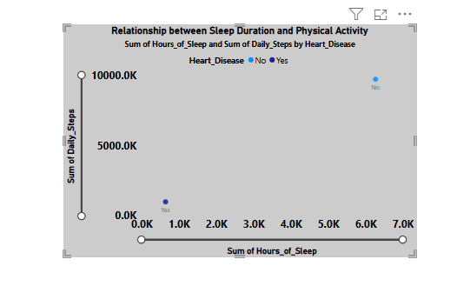

Ans 10.4

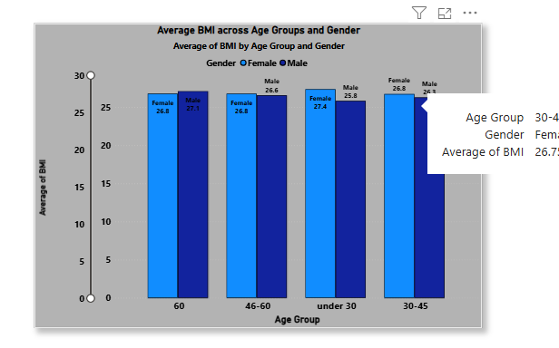

Ans.10.5

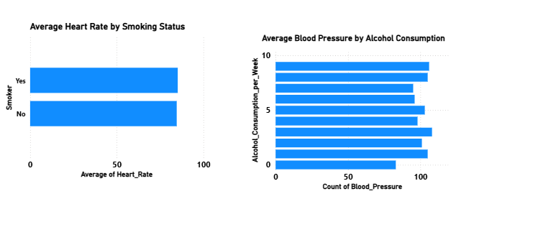

Ans.10.6

